28 января 2021 англ яз гр МЗ-2
Этот текст на тему «Телевидение: достоинства и недостатки» не соответствует заданной структуре. Надо перестроить его в соответствии с требованиями. В помощь предлагается размеченный ПЕРЕВОД этого текста (см. фото).
TELEVISION, ITS ADVANTAGES AND DISADVANTAGES.
Television now plays such an important part in so many people's lives that it is essential for us to decide whether it is a blessing or a curse. Obviously, television has both advantages and disadvantages. But do the former outweight the latter?
In the first place television, it is often said, keeps one informed about current events, allows one to follow the latest developments in science and politics, and offers an endless series of programs which are both instructive and stimulating. The most distant countries and the strangest customs are brought right into one's sitting-room. It could be argued that the radio performs this service just as well; but on television everything is much more living, much more real. Yet here again there is a danger. The television screen itself has a terrible, almost physical fascination for us. We get so used to looking at the screen, so dependent on its flickering pictures, that it begins to dominate our lives. It often happens that if your television set has broken down you and your family suddenly find that you have far more time to do things, and that you actually begin to talk to each other again. It makes one think, doesn't it?
There are many other arguments for and against television. The poor quality of some programs is often criticized. But it is undoubtedly a great comfort to many lonely elderly people.
Besides television is not only a convenient source of entertainment, but also a comparatively cheap one. For a family of four, for example, it is more convenient, as well as cheaper, to sit comfortably at home with practically unlimited entertainment available than to go out in search of amusement elsewhere. There is no transport to arrange, they do not have to find a baby-sitter. They do not have to pay for expensive seats at the theatre, the cinema, the opera or the ballet, only to discover, perhaps, that the show is a poor one. All they have to do is turn a knob, and they can see plays, films, operas and shows of every kind, not to mention political discussions and the latest exciting football match. Some people, however, think, that this is precisely where the danger lies. The television viewer needs do nothing. He doesn’t even use his legs. He makes no initiative. He makes no choice and exercises no judgement. He is completely passive and has everything presented to him without any effort on his part.
And does television corrupt or instruct the children? I think we must realize that television in itself is neither good nor bad. It is the uses to which it is put that determine its value to society.

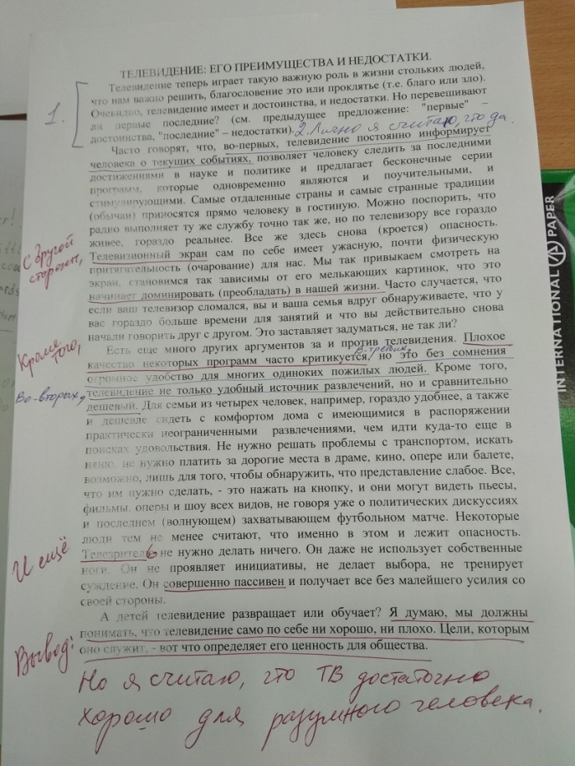
Пользуясь данной разметкой и текстом на английском языке, надо составить эссе в соответствии со структурой:
Вступление (Общее описание проблемы).
Своё мнение.
Аргументы ЗА своё мнение.
Аргументы ЗА противоположную точку зрения.
Вывод.
Обратите внимание: данная разметка далеко не идеальна
Первое, что нужно прислать мне ЛС – фото СВОЕЙ РАЗМЕТКИ текста.
Затем текст, переписанный или перепечатанный в соответствии с указанной структурой.
Скрин-шоты самостоятельной работы на сайтах прошу присылать ЛС VK.

