27 января 2021 г. английский язык гр ТО-3
1. Самостоятельная работа в U-dictionary: Aha Moment, Word Fishing, Spelling Check и любой раздел по Вашему выбору. Прислать скрин-шот и короткий отзыв о сегодняшней работе (что удалось, что не получилось, свои впечатления).
2. Самостоятельная работа в LinguaLeo: Выбрать текст для чтения, проделать словарную работу, выполнить минимум 2 тренировочных упражнения. . Прислать скрин-шот и короткий отзыв о сегодняшней работе (что удалось, что не получилось, свои впечатления).
3. Самостоятельная работа на сайте Cake (тренировка фраз на английском языке). Прислать скрин-шот и короткий отзыв о сегодняшней работе (что удалось, что не получилось, свои впечатления).
4. Самостоятельная работа на сайте Puzzle English. На этом сайте задание для всех:
https://vk.com/im?peers=523352200_585714812&sel=c71&z=video-44923655_456239979%2Fd24251be7ec7b8b1b9
После просмотра и/или изучения ролика напишите своё мнение о РОЛИКЕ (не путайте: не о Байдене и не об английском вообще, а именно об этом ролике). Что полезное Вы нашли в нём для себя?
5. Для желающих ознакомиться с различными методиками изучения иностранного языка: https://vk.com/im?peers=c59_509065749_c71_523352200_585714812_c63&sel=c68
6. Вспомнить работу над эссе «Телевидение: зло или благо,»
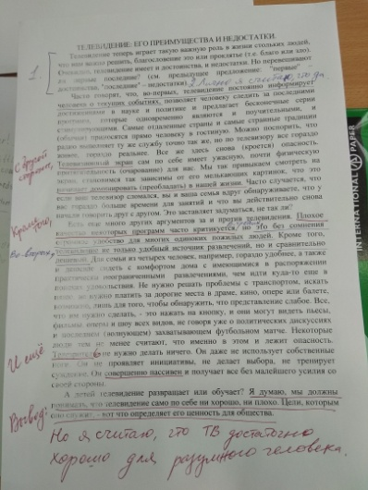Это фото нашего вспомогательного рабочего текста.
TELEVISION, ITS ADVANTAGES AND DISADVANTAGES.
Television now plays such an important part in so many people's lives that it is essential for us to decide whether it is a blessing or a curse. Obviously, television has both advantages and disadvantages. But do the former outweight the latter?
In the first place television, it is often said, keeps one informed about current events, allows one to follow the latest developments in science and politics, and offers an endless series of programs which are both instructive and stimulating. The most distant countries and the strangest customs are brought right into one's sitting-room. It could be argued that the radio performs this service just as well; but on television everything is much more living, much more real. Yet here again there is a danger. The television screen itself has a terrible, almost physical fascination for us. We get so used to looking at the screen, so dependent on its flickering pictures, that it begins to dominate our lives. It often happens that if your television set has broken down you and your family suddenly find that you have far more time to do things, and that you actually begin to talk to each other again. It makes one think, doesn't it?
There are many other arguments for and against television. The poor quality of some programs is often criticized. But it is undoubtedly a great comfort to many lonely elderly people.
Besides television is not only a convenient source of entertainment, but also a comparatively cheap one. For a family of four, for example, it is more convenient, as well as cheaper, to sit comfortably at home with practically unlimited entertainment available than to go out in search of amusement elsewhere. There is no transport to arrange, they do not have to find a baby-sitter. They do not have to pay for expensive seats at the theatre, the cinema, the opera or the ballet, only to discover, perhaps, that the show is a poor one. All they have to do is turn a knob, and they can see plays, films, operas and shows of every kind, not to mention political discussions and the latest exciting football match. Some people, however, think, that this is precisely where the danger lies. The television viewer needs do nothing. He doesn’t even use his legs. He makes no initiative. He makes no choice and exercises no judgement. He is completely passive and has everything presented to him without any effort on his part.
And does television corrupt or instruct the children? I think we must realize that television in itself is neither good nor bad. It is the uses to which it is put that determine its value to society.
Это текст, по которому мы писали эссе. Просто вспомнить, как мы это делали.
7. Написать эссе на английском языке на тему «Изучение иностранного языка». Возможные варианты темы:
А) Английский или китайский?
Б) Владеть языком или пользоваться электронным переводчиком?
В) Иностранный язык нужен для работы или для отдыха?
Структура эссе:
Вступление (Общее описание проблемы).
Своё мнение.
3 аргумента за своё мнение.
2-3 аргумента за противоположную точку зрения.
Вывод.

